

# School of Computing

**SRM IST, Kattankulathur – 603 203**

**Course Code: 18CSC206J**

**Course Name: Software Engineering and Project Management**

|  |  |
| --- | --- |
| **Experiment No** | 8 |
| **Title of Experiment** | Develop a Data Flow Diagram (Process-Up to Level 1) |
| **Name of the candidate** | Dhruv Deshmukh |
| **Team Members** | Atharva Sohani (RA2111028010105)  Papai Mondal (RA2111028010116) |
| **Register Number** | RA2111028010125 |
| **Date of Experiment** | 04/04/23 |

**Mark Split Up**

|  |  |  |  |
| --- | --- | --- | --- |
| **S. No** | **Description** | **Maximum Mark** | **Mark Obtained** |
| 1 | Exercise | 5 |  |
| 2 | Viva | 5 |  |
| **Total** | | **10** |  |

# Staff Signature with date

## Aim

To develop the data flow diagram up to level 1 for the OTT Recommendation System.

## Team Members:

|  |  |  |  |
| --- | --- | --- | --- |
| **S No** | **Register No** | **Name** | **Role** |
| **1** | RA2111028010125 | Dhruv Deshmukh | **Rep** |
| **2** | RA2111028010116 | Papai Mondal | **Member** |
| **3** | RA2111028010105 | Atharva Sohani | **Member** |

**DFD Level 0**

Context-level DFD for the recommendation system function.

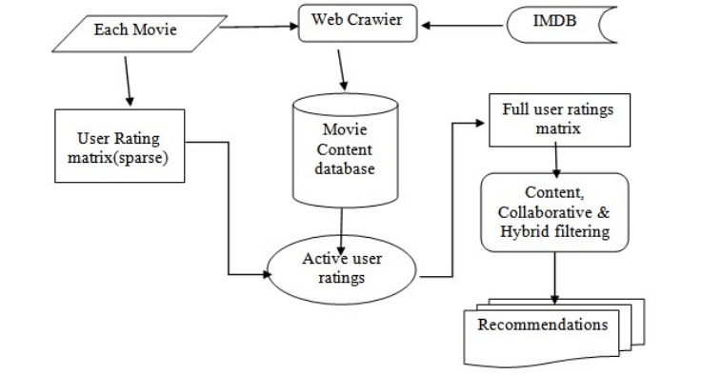

**DFD Level 1**

Level 1 DFD for the movie recommendation system function.

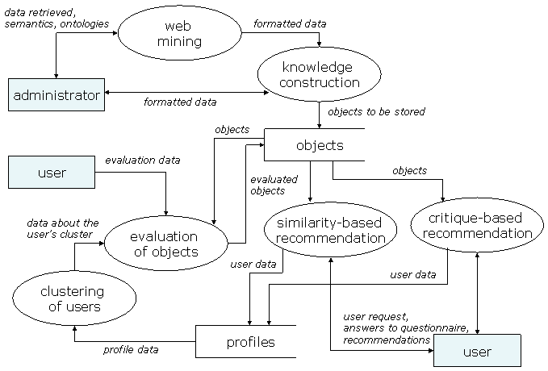

## Data Flow Diagram

The DFD takes an input-process-output view of a system. That is, data objects flow into the software, are transformed by processing elements, and resultant data objects flow out of the software. Data objects are represented by labeled arrows, and transformations are represented by circles (also called bubbles). The DFD is presented in a hierarchical fashion. That is, the first data flow model (sometimes called a level 0 DFD or context diagram) represents the system as a whole. Subsequent data flow diagrams refine the context diagram, providing increasing detail with each subsequent level.

The data flow diagram enables you to develop models of the information domain and functional domain. As the DFD is refined into greater levels of detail, you perform an implicit functional decomposition of the system. At the same time, the DFD refinement results in a corresponding refinement of data as it moves through the processes that embody the application.

A few simple guidelines can aid immeasurably during the derivation of a data flow diagram:

1. Level 0 data flow diagram should depict the software/system as a single bubble;
2. Primary input and output should be carefully noted;
3. Refinement should begin by isolating candidate processes, data objects, and data stores to be represented at the next level;
4. All arrows and bubbles should be labeled with meaningful names;
5. Information flow continuity must be maintained from level to level and
6. One bubble at a time should be refined. There is a natural tendency to overcomplicate the data flow diagram. This occurs when you attempt to show too much detail too early or represent procedural aspects of the software in lieu of information flow.

## */ For Example DFD Level 0

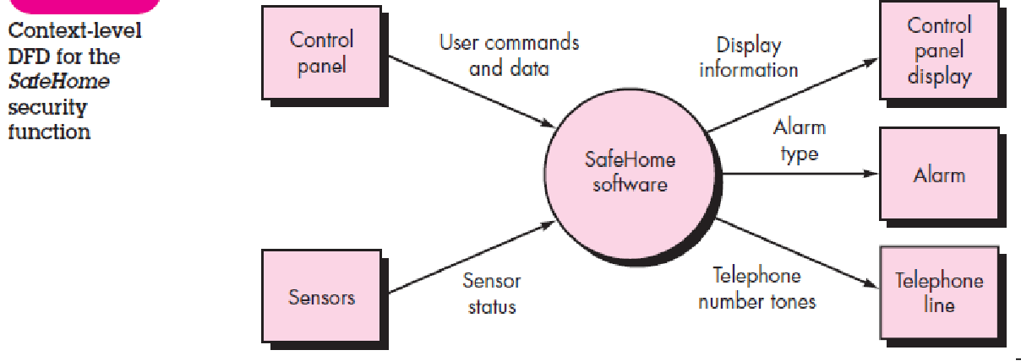

**DFD Level 1**

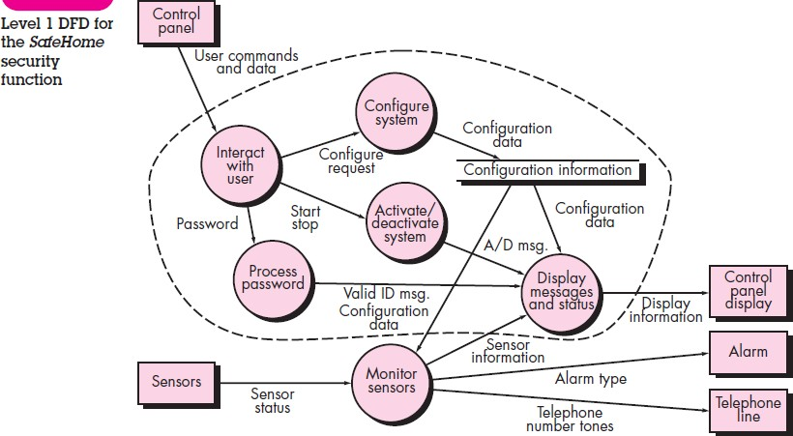

**Result:**

Thus, the data flow diagrams have been created for the OTT Recommendation System.